
Exhibitor Manual Toolkit

Event: School Leaders Scotland Association Annual Conference 2024

As part of your exhibition, all exhibitors must be issued an exhibitor manual. The exhibitor manual is a vital method of communication to inform your exhibitors, not only of the additional services available, but also highlights vital information on Health & Safety and the venue and informs exhibitors on their responsibilities.

About P&J Live
Getting to P&J Live
P&J Live, The Event Complex Aberdeen, East Burn Road,
Stoneywood, Aberdeen. AB21 9FX

P&J Live enjoys excellent road, rail, and air transportation links. The complex is conveniently situated off the A96 Aberdeen to Inverness Road and is close to the AWPR for access from the South. Aberdeen Airport is just 1.5 miles away. Flight connections are available to London airports, most other UK airports and Northern Europe.

Bus Services
Stagecoach Service 727 runs from Aberdeen City Centre to Aberdeen Airport every 15 minutes. Further information can be found on www.stagecoachbus.com

Vehicle Parking
Pay & Display is in operation at P&J Live. For further details on tariff information and how to pay, please visit our website: https://www.pandjlive.com/visiting/parking/
Please note that vehicles may not be left overnight without pre-arrangement with the P&J Live Event Manager, via the exhibition organisers.

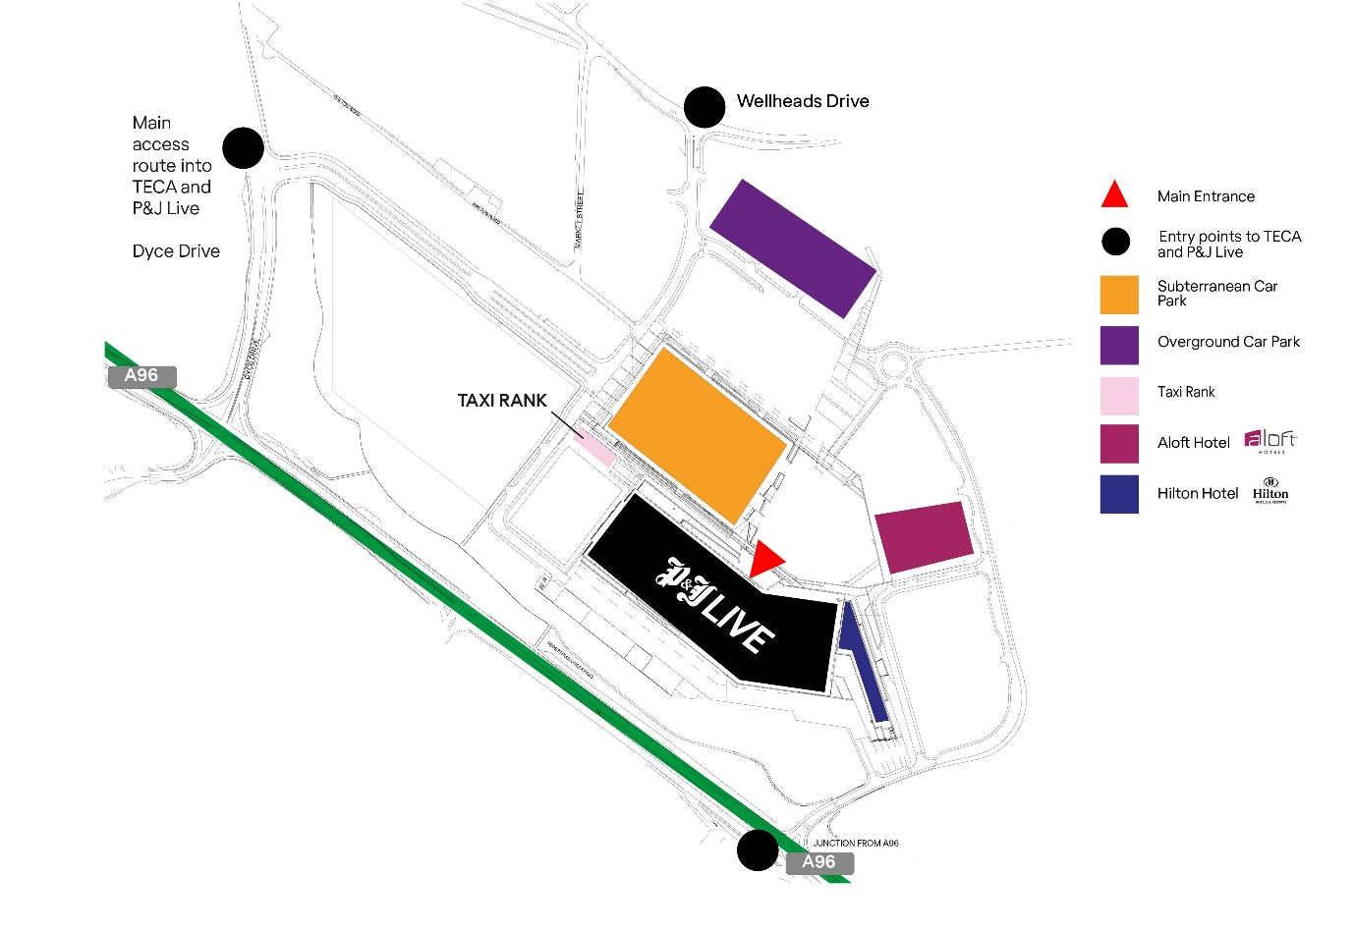

Entry Information
Exhibitors should enter the building from the SUBT Car Park or the Main Entrance doors. If you have any items which cannot be hand carried or transported by trolley, please contact Madeline Lenthall, mlenthall@pandjlive.com

Exhibition Timetable
Build Up Information
Build Up | Build Close
TBC | TBC

Break Down
Show Close Time | Breakdown Hours
14.30 | 14.30

Please note: For safety reasons, breakdown must not commence before the official end of show time as stated above and until all visitors have left the room.
All exhibitors must clear their stands by 15.30
Any remaining items will be removed and either destroyed, or stored at the exhibitor’s expense.

Exhibition Stands
Table Top
What you get: Carpeted Area with One Table and 2 x chairs

No stand fitting or display features may exceed 2.5m in height. If in doubt, please contact Madeleine Lenthall, MLenthall@pandjlive.com
Please note: For safety reasons, breakdown must not commence before the official end of show time as stated above and until all visitors have left the hall.

Deliveries to P&J Live and Post Show Collections
Pre-Show Deliveries
All exhibitors must observe the delivery times and ensure deliveries arrive no earlier than Tuesday 12th November 2024. Any deliveries that arrive before this date may be refused, or stored at the exhibitor’s expense.

Deliveries must be addressed as follows:
COMPANY NAME & STAND NUMBER
SLS 2024 - CS2
P&J Live,
The Event Complex Aberdeen,
East Burn Road,
Stoneywood,
Aberdeen
AB21 9FX

P&J Live cannot be held responsible for any deliveries which are not addressed correctly.
If shipping from outside the UK, we recommend that you ship via a Customs Agent, as the venue cannot get involved in any customs issues.
Please note that during the show, under normal circumstances, no goods may be delivered to or removed from stands during the open hours of the exhibition. If this is necessary, permission must be sought from the organiser and the P&J Live Event Manager.
Forklifting
If any deliveries requiring forklifting, please contact Madeleine Lenthall, MLenthall@pandjlive.com.
Please note, there is a charge for each forklift drop which is required to be paid in advance of the show. Failure to arrange and make payment may result in your items being refused.

Post Show Collections
Any items being collected by a courier must be securely packaged, clearly labelled and left on your stand, along with the completed courier collection form, which can be found on the next page.
It is your responsibility to ensure that couriers collect by close of business on Monday 18th November 2024 (1 DAY POST SHOW). Any packages not collected by this time will either be destroyed or stored at the exhibitor’s expense.

Stand Builds
Please ensure you have all equipment to build and breakdown your stand or exhibit, including parcel tape to package up any items which are being collected by courier. P&J Live take no responsibility in building or breaking down any exhibition stands or exhibits.

COURIER COLLECTION FORM
Any items being collected by a courier must be securely packaged, clearly labelled and left on your stand, along with the completed courier collection form.
It is your responsibility to ensure that couriers collect by close of business on Monday 18th November (1 DAY POST SHOW). Any packages not collected by this time will either be destroyed or stored at the exhibitor’s expense.
Leave this form with your packages on your stand.
SHIPPER
Name of the Company
Address

Contact person | Name |  | Phone
COURIER
Name of the Company
COLLECTION
Date and time slot of Collection*

Pick up Point | Hall | Number of Booth | Name on Booth
Items | Quantity | Description of Package(s)
Special Instructions
(if any)
 | I confirm the details above are correct.
Please,
tick the box
Form Filled by | Name |  | Company
 | Signature |  | Date

Essential Information

Exhibitor Online Shop
The P&J Live Exhibitions Online Shop can offer a catalogue of items, including electrics, floorcovering and AV. Items are ordered and paid for directly, offering a secure method. The online shop remains open until 2 days before the event.
A full range of audio-visual equipment can be hired for the duration of the exhibition. This can be ordered using the online shop at https://www.pandjlive.com/attending/event-ordering/. For any requirements not available through the online shop, please contact Madeleine Lenthall, MLenthall@pandjlive.com

Cleaning and Waste Disposal
Exhibitors are responsible for keeping stands tidy and for ensuring that waste is deposited in accordance with the rules on waste disposal. For health & safety reasons it is important that all exhibitors and contractors keep aisles and walkways clear of rubbish at all times. Any items left in the aisles are subject to being cleared away, regardless of whether they are waste or not.
Cleaning of public aisles and common areas will take place the evening before show open. Where possible, stands will also have light vacuuming.
Additional cleaning work can be requested, and costs provided on application by contacting Madeleine Lenthall, MLenthall@pandjlive.com

Electric Lighting and Power
The installation or alteration of any electrical installation or fitting by any person other than a member of P&J Live’s in-house Electrical Services Team is strictly prohibited. In accordance with current health & safety legislation all electrical equipment and fittings should comply with applicable test regulations.

Emergency Exits, Routes and Assistance
Evacuation routes/emergency exits must not be blocked at any time. Under no circumstances is this acceptable. No displays, posters or similar materials which might interfere with sight lines or fall down in the event of fire may be hung in evacuation routes or their vicinity.
Fire stations must be visible and accessible at all times. They must not be covered or blocked. Fire stations can be fire hoses, fire extinguishers or fire alarm points.

Fire Prevention
Temporary furnishings and decorations must be in non-flammable materials, or fireproofed in line with the relevant regulations. Flammable gases/liquids/objects may not be used or stored indoors without relevant documentation and approval from the organiser and the P&J Live Event Manager. Use of fire or naked lights (including candles) is strictly prohibited.

First Aid
Any person requiring first aid treatment should contact the organiser’s office or any member of P&J Live staff.

Health and Safety
The exhibition hall(s) is classed as a building site during build up and break down. During this time, all exhibitors and their contractors must comply with P&J Live rules. At no time will children under the age of 16 be permitted in the halls during build up and breakdown.
As part of the Association of Event Venues (AEC), P&J Live adheres to the policies within the eGuide. The eGuide brings together guidance for achieving common standards of health, safety and operational planning, management and on-site conduct for events at all participating AEV member venues. The scope and development of the eGuide follows extensive consultation with operations professionals within the exhibition and event industry in order to ensure an overall approach that remains broadly acceptable to the community. The status of the eGuide is similar to that of an Approved Code of Practice. It is an industry specific guide, developed by authorised professionals from the UK’s event venues. It incorporates health, safety and operational practices that represent compliance with building regulations and health & safety legislation.
For further information, please visit www.aev.org.uk/eguide.

Insurance
Exhibitors must ensure all necessary insurance cover for damage to their own goods and for possible liability in respect of injury to third parties or damage to third-party property, including the property of the venue. In some cases public liability insurance is also required.

Playing Music on Stands
If you intend to play recorded background music on your stand during the course of the exhibition, you are required by law to obtain music licenses.
Phonographic Performance Ltd (PPL) administers licensing of sound recording for most recorded music played within the UK. It issues a license and levies a tariff on the broadcast and public performance (which includes exhibition stands) on behalf of the record companies.
Performing Rights Society (PRS) administers licensing of sound recording and performances for most music played in the UK. It issues a license and levies a tariff on the broadcast and performance (which includes exhibition stands) on behalf of the writers and publishers of music.
Exhibitors are solely responsible for obtaining any license required to play music on their stand. These can be obtained by contacting PPL and PRS direct.
It is recommended that licenses are applied for a minimum of 28 days prior to the event open date.
PPL: Applications can be made online via the PPL website: www.ppluk.com
PRS: Applications can be made via the telephone: 0800 068 4828. Further information can be found via the PRS website: www.prsformusic.com

Presentations on Stands
Exhibitors must ensure that neighbouring stands are not obstructed or disturbed by the use of audio and audio visual equipment, working machinery or other presentations.

Public Address System
The public address system is for official announcements only and is not available to exhibitors for publicity purposes or individual messages.

Rigging
All submissions for rigging must be supported by plans and structural details of all elements to be rigged.
Rigging is only permitted by trained & authorised P&J Live staff. P&J Live reserve the right to refuse any items to be rigged if they are deemed to be unsafe or if insufficient information is provided.

Security
Security is provided for the event during build, open period and breakdown, however, the organiser and P&J Live accept no responsibility for any loss or damage to personal belongings or equipment and advise that exhibitors and their contractors are adequately covered.

Smoking
Under Scottish Law, smoking is strictly prohibited in the exhibition hall(s) and must take place in the designated outdoor areas. Any reports of smoking indoors should be made to the P&J Live Event Manager immediately. Cigarette end bins are available at all designated smoking areas and must be used.
The use of e-cigarettes is strictly prohibited indoors at P&J Live.

Water Features
If you are intending to use a water feature on your stand, please confirm the details in writing to the venue in advance, as written approval is required. This ensures that the correct precautions are taken to minimise the spread of legionella bacteria. Charges for filling and emptying of water features apply. Please email Madeleine Lenthall, MLenthall@pandjlive.com

Wi-Fi
P&J Live offer visitors a complimentary Wi-Fi service. To connect, select P&J Live Free Wi-Fi network. This service is suitable for light browsing only.
If you require a dedicated bandwidth, please contact Madeleine Lenthall, MLenthall@pandjlive.com

